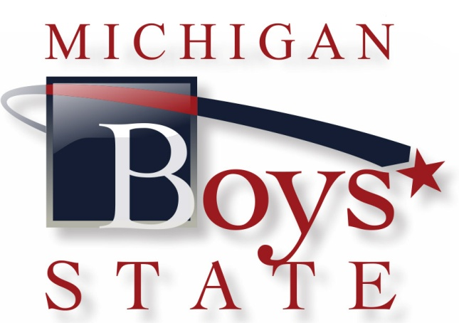

The following letters were composed by Post 28 in Grand Haven. They have successfully sent a large number of Boys State attendees annually and are willing to share their tips. Please use them as a guide to recruiting both attendees and sponsors. Use post letterhead on letters.

- Start early.
- Review Post files for names of school contacts, recent sponsors or donors.
- It's critical to establish a relationship with the Principal, Counselors, or Teachers a the local H.S. Start in October/November to do this. You must have a champion at the school to promote/administer Boys State.
- meet the Delegate Nominees at the school after they are nominated. Include a Senior student who attended Boys State in the meeting. Let them talk!
- Be ready to provide printed material or web sites to answer any questions.
- See that every service club (Elks, Rotary, etc.) knows about Boys State. Make a presentation at their meetings if possible. They are great year after year supporters.
- Get a current vusiness directory, and start selling. (Calls, letters, phone contacts, etc.)
- Make personal calls in uniform.
- Keep good computer records so it's easier for next year.
- Use the information and forms found on National and Department of Michigan websites.

Dave Carlson, Vice Commander & Boys State Chairman
American Legion Post 28 Grand Haven, MI 49417

Today's Date

Counselors Name
School's Name
School's Address
City, MI Zip code

Dear Counselor:

Another school year is already here. Where has the summer disappeared to so fast? I am the 2015 Boy's State Chairman for the American Legion Post XXX in XXX.

I will be contacting you in the near future about your school's participation in the 2015 Boy's State Program being held at Northwood University in Midland, Michigan.

Please contact me anytime if you have any questions or suggestions.

Thank you for your help to provide XX HS students with a "week that shapes a lifetime".

Sincerely,

(Insert Name)
Boy's State Chairman, Post XXX

Today's Date

Principal's Name
School's Name
Address
City, MI Zip code

Dear Principal:

Where do leaders come from?

I'm writing to request a brief visit with you to discuss The American Legion program, Boys State, described in the enclosed brochure.

We supply the funds, and ask you to recommend qualified junior year candidates. Michigan High Schools send about 250 - 300 students to Boys State each year.

These Boys-staters return for their Senior year prepared for leadership roles in their school; and significant accomplishments later in life.

I'll phone next week for a time and day when you might be available to discuss this.

Thank you for your consideration.

Sincerely,

(Insert Name)
Boys State Chairman, Post XXX

Encl.

Today's Date

Dear XXXX:

Neil Armstrong, Michael Jordan, Bill Clinton, Chris Christie, Tom Brokaw, and Jon Bon Jovi once had names that few people knew. These and many other famous men attended an American Legion Boys State program as juniors in high school because someone like you encouraged and sponsored them.

This year, Boys State will be held during the week of June 14 - 20, 2015 at Northwood University in Midland, Michigan. The enclosed brochure explains the Boys State program.

You have the opportunity to make a positive difference in a young personals life. Following are the names of XX High School Students who were nominated by their counselors and teachers:

John D. Andy S. Charles W. Thomas D.
Harry P. Ron L. Max S. Ron W.

They may never become world famous names, but you could take satisfaction in knowing one of our brightest and best was encouraged along the way by your sponsorship.

Choose to sponsor one or more of these delegates this year. We want to send as many as possible. The cost is $325 per student. Please make checks payable to American Legion Post XXX.

Thank you very much for your consideration of this request. We really need your help since it's impossible for us to fund these programs without community support.

Sincerely,

(Insert Name)
Boys State Chairman Post XXX

Encl.

Today's Date

Dear XXX:

We're writing to ask you to sponsor XX High School Juniors selected by their teachers to attend Boys State. American Legion Boys State is a nationwide educational program that for 77 years has given outstanding young men a unique opportunity to learn leadership skills, and practice how city, county, and state government work. This year, Boys State will be held during the week of June 14 - 20, 2015 at Northwood University in Midland, Michigan. Our fundraising deadline is April 15th, 2015.

The enclosed brochure explains more about the program for Boys State.

Will you sponsor one or more of our Delegates the year? The cost is $325 per student. Please make checks payable to Post XXX. If you have any questions contact me at my home number XXX-XXX-XXXX, or by email XXXXXX.

Thank you very much for your consideration of this request. We really need your help since we expect to have a total of XX nominations form the schools. It's impossible for us to fund these programs without support from the business community.

Sincerely,

(Insert Name)
Boys State Chairman, Post XXX

Encl.

Today's Date

XXXX:

Dear Delegate:

Congratulations! It's an honor, and a great opportunity, to be nominated by your teachers and counselors to attend the American Legion Boys State Program. We're delighted to sponsor you to Boys State, and we are grateful to the people, organizations and businesses that make this possible with their financial support. (I'll provide the name of your sponsor at a later date.)

We provide free bus transportation for the American Legion Post XX (insert address of post) to Northwood University in Midland, MI. The bus will leave promptly at 7:00 a.m. Sunday, June 14th and return Saturday afternoon, June 20th. You must let me know if you choose another way to travel.

Questions? Please see www.michiganlegion.org/boysstate for resources, what to bring FAQ's, etc. I'll use this email address to get in touch with you: XXXXXX

Some think leader are born not made. Not me! Boys State is described as "A week that shapes a lifetime". This hands-on experience is known for imparting citizenship, leadership, and character development skills. It will help prepare you for your future studies and career.

Best wishes for your continued success,

(Insert your name)
Boys State Chairman, Post XXX

Today's Date

Post Commander:

We sure could use some help to fund the Boys State Program this year. We have XX boys nominated from our two local high schools; and sponsors for only XX of them. These fine young men and all been recommended by their counselors, and would inspire you if you had a chance to meet them.

Educators have seen how Boys State Delegates come back for their senior year ready to lead, and to be positive role model for other students. The Legion has many wonderful programs. Boys State is terrific to promote values such as Americanism and character development. We work hard at it.

One thing that helps is to start early by contacting the school principal or counselors in October. It's critical to gain the cooperation of teachers and the administration to nominate their brightest and best. And to provide a time in November or December for a meeting with those nominated. (It's good to have a Boys Stater from the previous year at the meeting.) Meantime, we contact businesses and service clubs to find sponsors. There's lots of good information on the National and Department of Michigan web sites (www.michiganlegion.org/boysstate) to promote Boys and Girls State Programs.

Please help us with your support of these XX nominees so as many as possible will be able to attend. Thanks for your consideration.

Sincerely,

(Insert Name Here)
XX District Boys State Chairman

